**CSS ASSIGNMENT**

**1. What are the benefits of using CSS?**

Ans:-

CSS is used for styling give to the HTML elements.

Css to change all screen type them elements.

Css to give thme element animations and transitions.

Ex:-

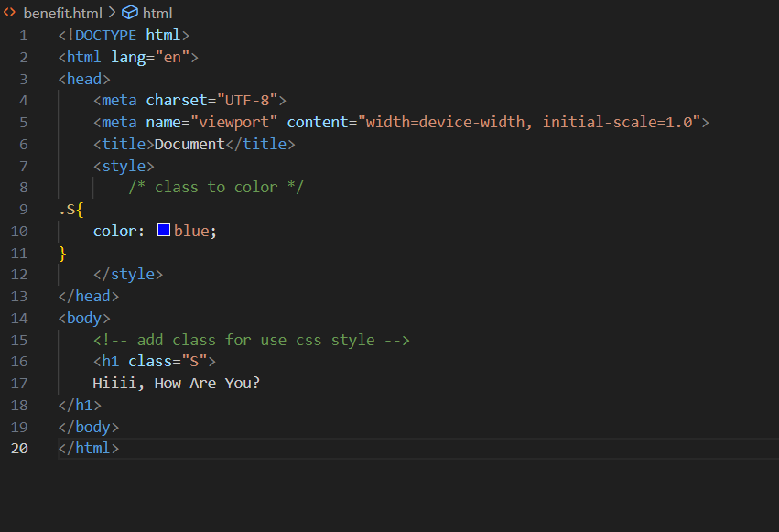

Output:-

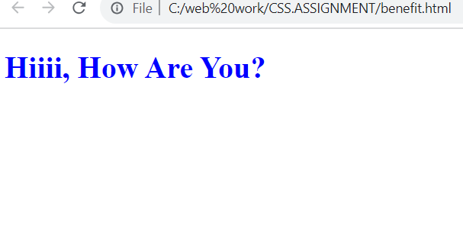

**2. What are the disadvantages of CSS?**

Ans:-

* Using multiple Css files can take long time to load the web page.
* Css is work with one browser might not always work with another.
* The similar change affects on all browser.

**3. What is the difference between CSS2 and CSS3?**

Ans:-

* The breakdown code in modules in css3 but not in css2.
* css2 only web safe fonts can be used
* special font use css3 but not use in css2
* New ways for writing in css2 but not in css3
* Creating responsive design is not possible in css2 but possible in css3.
* css3 the selector were called as a sequence of simple selectors.com

**4. Name a few CSS style components**

Ans:-

The CSS style components are Attributes, Buttons, Cards, Navigation bar, Forms, Value of Properties, Margin, Padding etc.

Ex:-

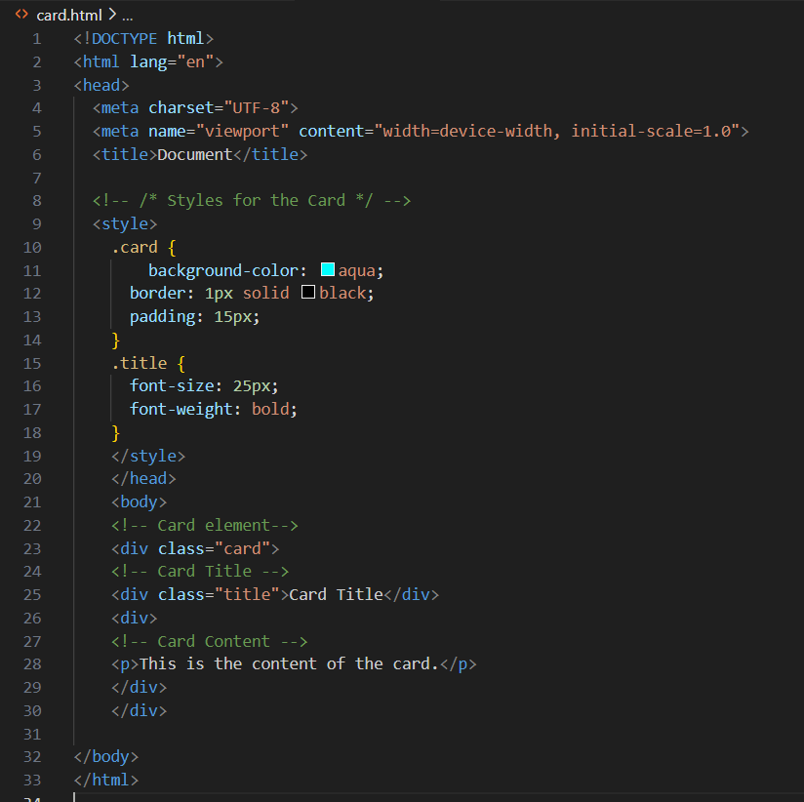

Output:-

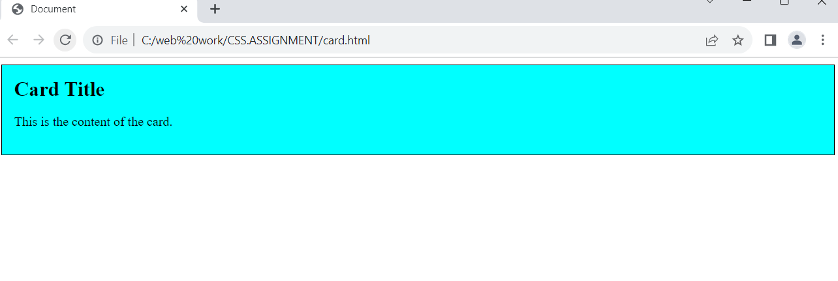

**5. what do you understand by css opacity**

Ans:-

The opacity is used for the transparency of an element.

opacity is the degree to which content behind an element is hidden.

Opacity’s ranges from 0 to 1, where 0 is completely invisible and 1 is completely visible.

Ex:-

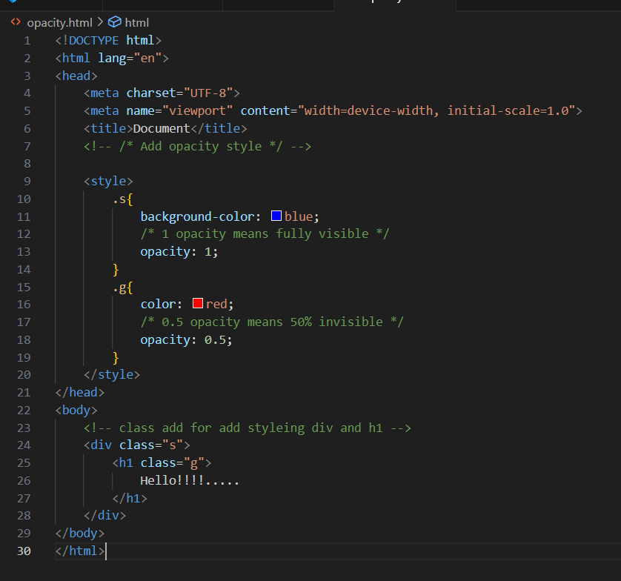

Output:-

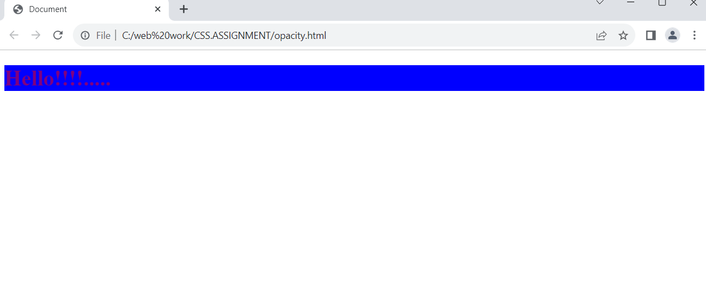

**6. How can the background color of an element be changed ?**

Ans:-

Change the background color in element by use the background-color property.

Ex:-

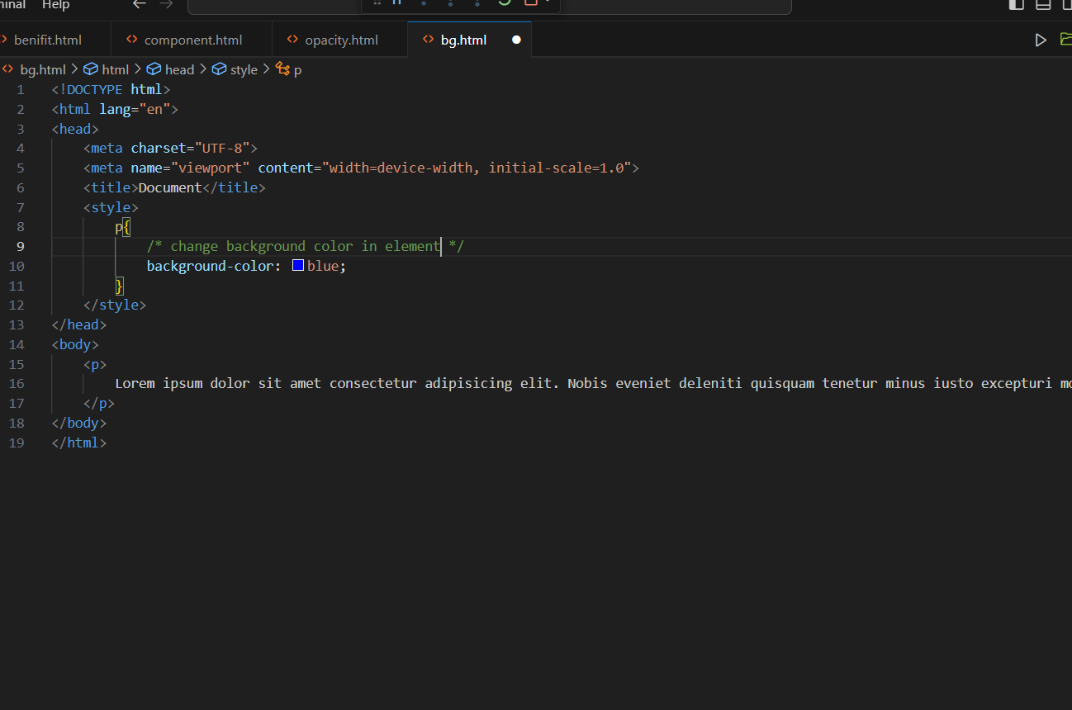

Output:-

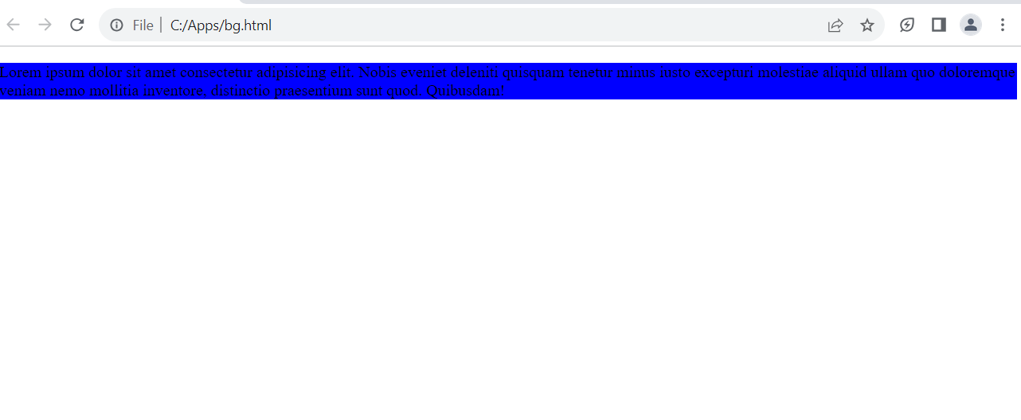

**7. How can image repetition of the backup be controlled?**

Ans:-

` **background-repeat:** ’ This property to controlled image repetition.

Ex:-

**1.Repeat:-**

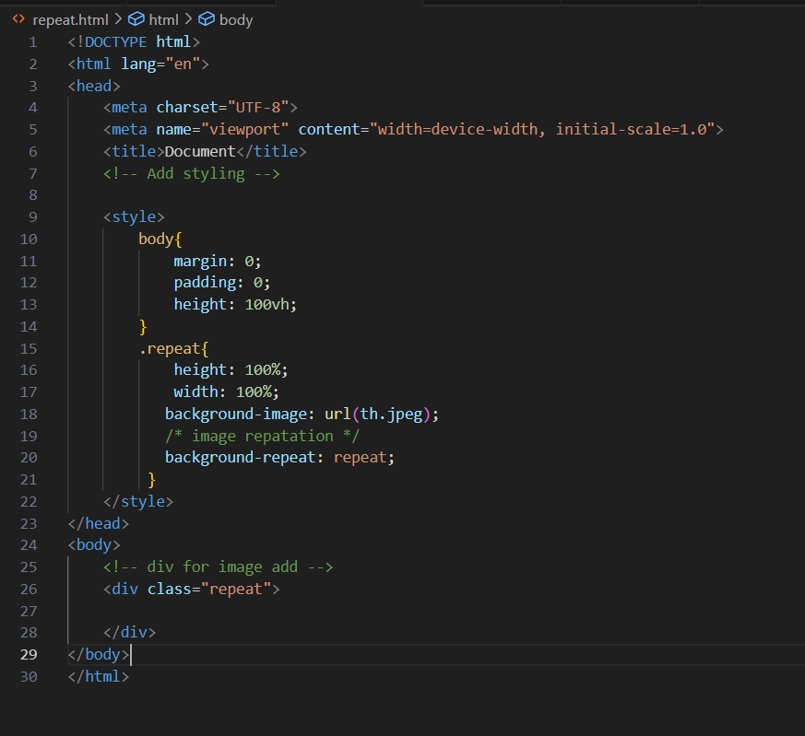

Output:-

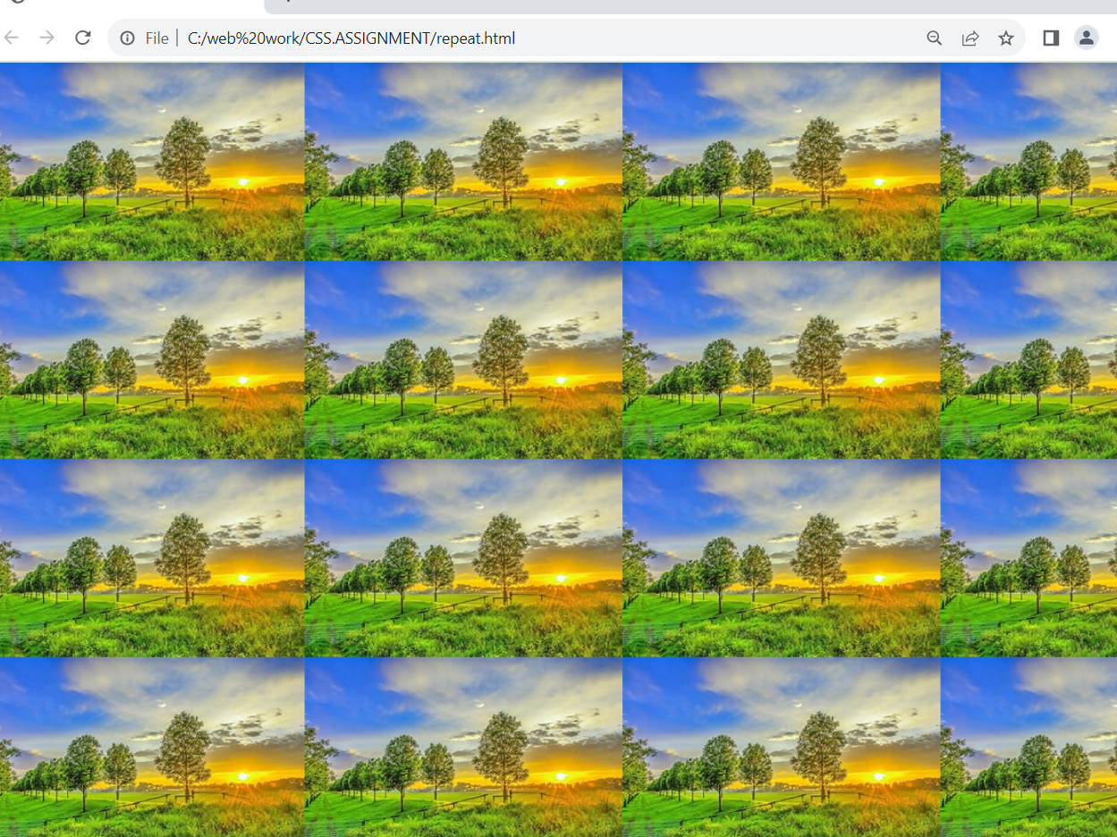

**2.No repeat**

Ex:-

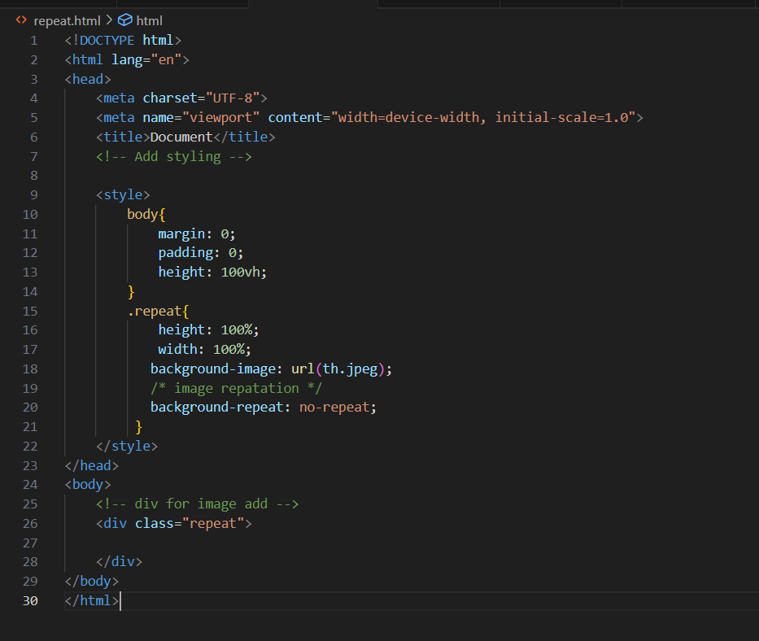

Output:-

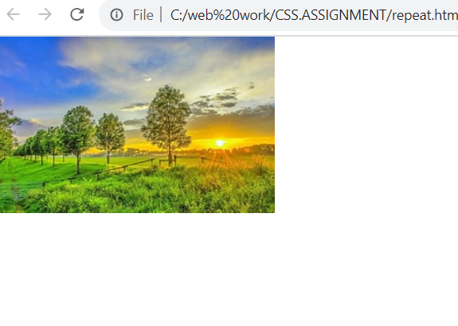

**8. What is the use of the background-position property?**

Ans:-

* The background-position property is used to move the background image around within its container.
* background-position property is used to put the position in the 4 directions top, left, right, bottom.

Ex:-

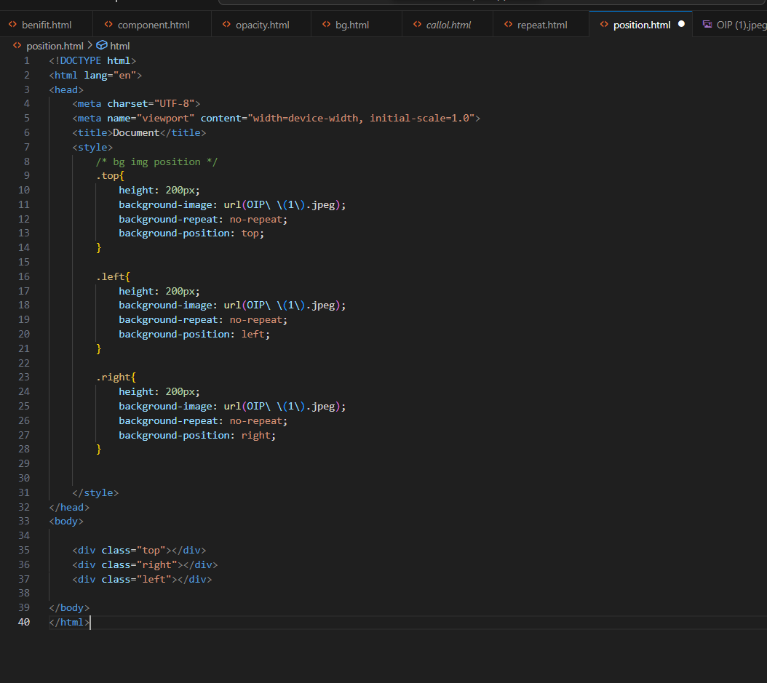

Output:-

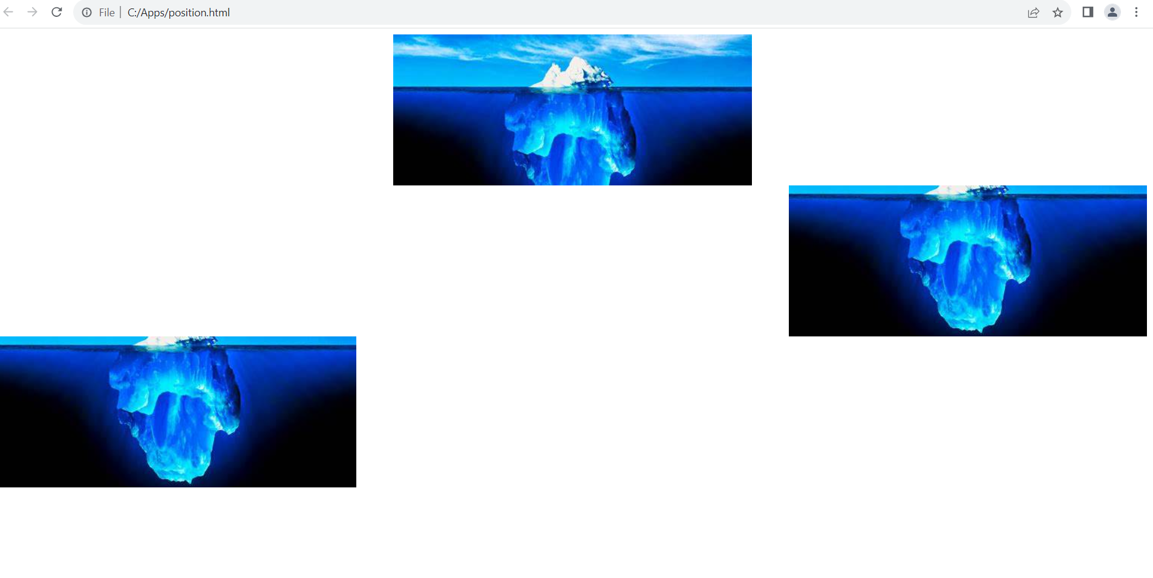

**9. Which property controls the image scroll in the background?**

Ans:-

The property controls the scrolling behavior of a background image is the **background-attachment** property in CSS.

Ex:-

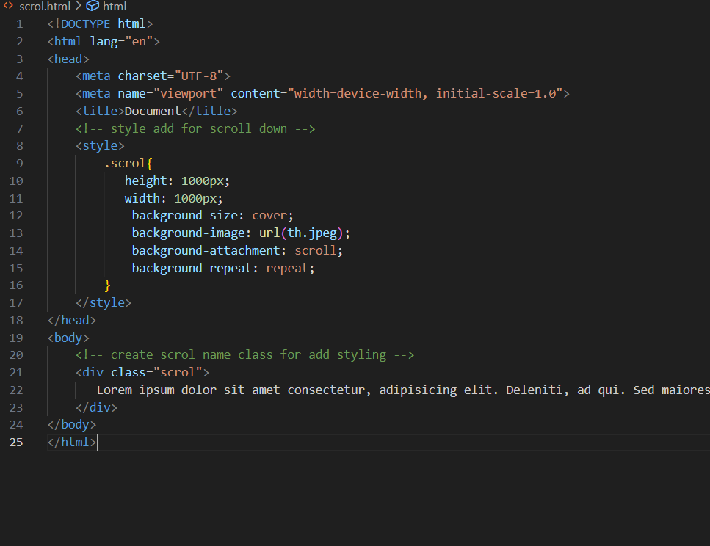

Output:-

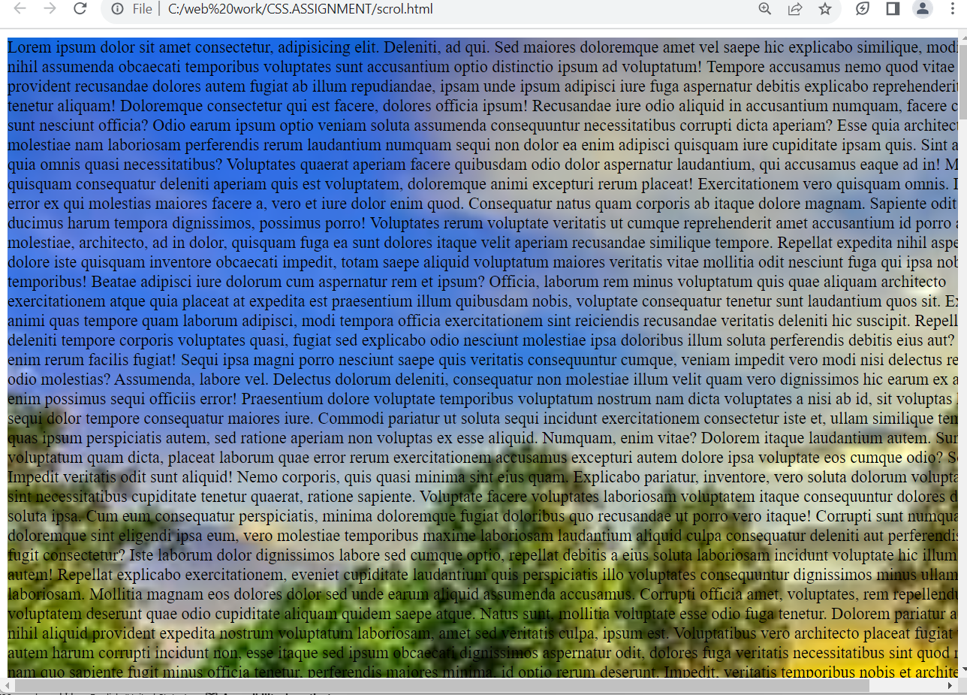

**10. Why should background and color be used as separate properties?**

Ans:-

* The background-color property to change the color of the background, while color property is only used to change the color of the font.

Ex:-

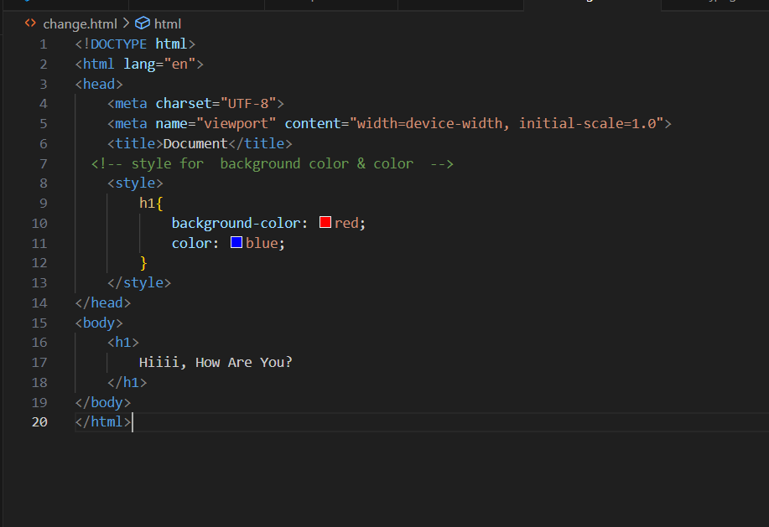

Output:-

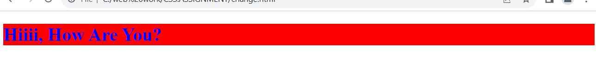

**11. How to center block elements using CSS1?**

Ans:-

* Css1 in center block element for using **‘text-align’** property for the parent container and The margin property for the block element to center.

Ex:-

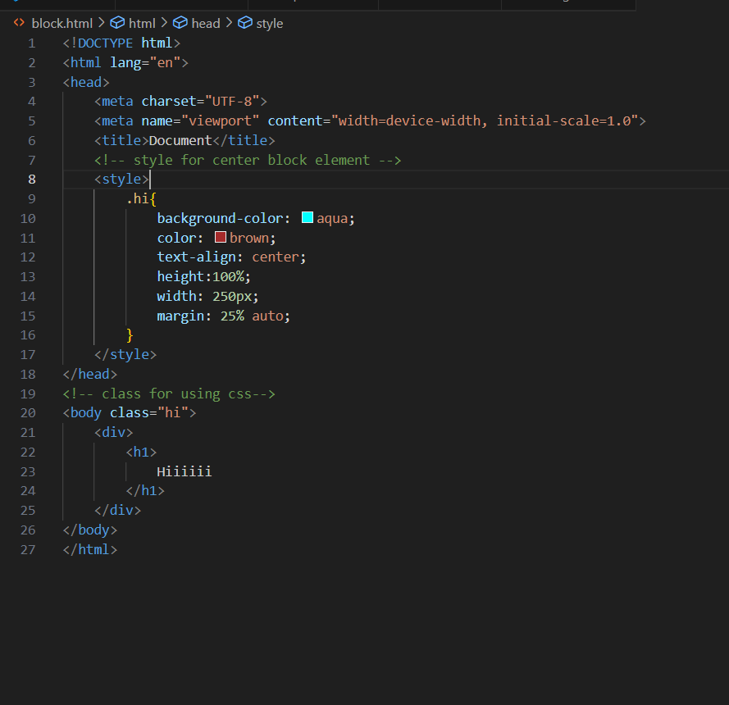

Output:-

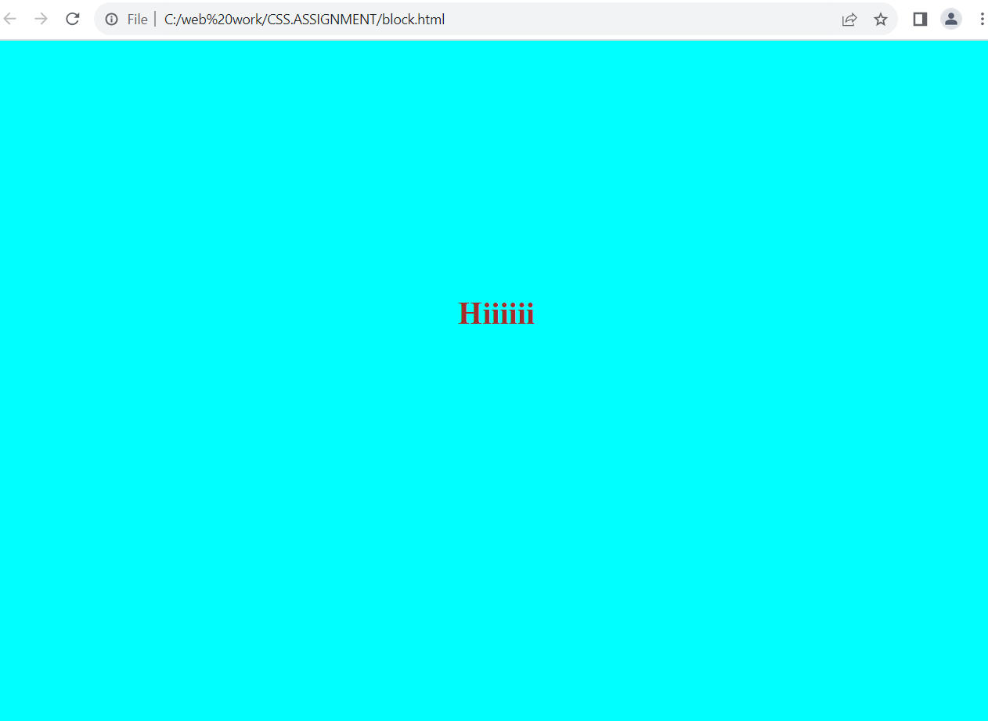

**12. How to maintain the CSS specifications?**

Ans:-

* Maintaining CSS specifications involves ensuring that your stylesheets adhere to best practices, follow a consistent coding style, and are compatible with the latest web standards.
* The css specifications Stay updated, Follow best practices, use css preprocessor, version control, modularize css, testing and validation, code reviews and stay engaged.
* The css code is larger than 400 lines then the html could should use external css file.

**13. what are the ways to integrate css as a web page?**

Ans:-

* There are three ways to integrate css in the web page.

1. Inline CSS:-

<h1 style= “color:red”>Hello, World!</h1>

1. Internal CSS:-

<style> h1{color: red}; </style>

1. External CSS :-

<link rel="stylesheet" href="style.css">

**14. What is embedded style sheets?**

Ans:-

* Embedded style sheets means css code inside the style tag in the same html document.

Ex:- 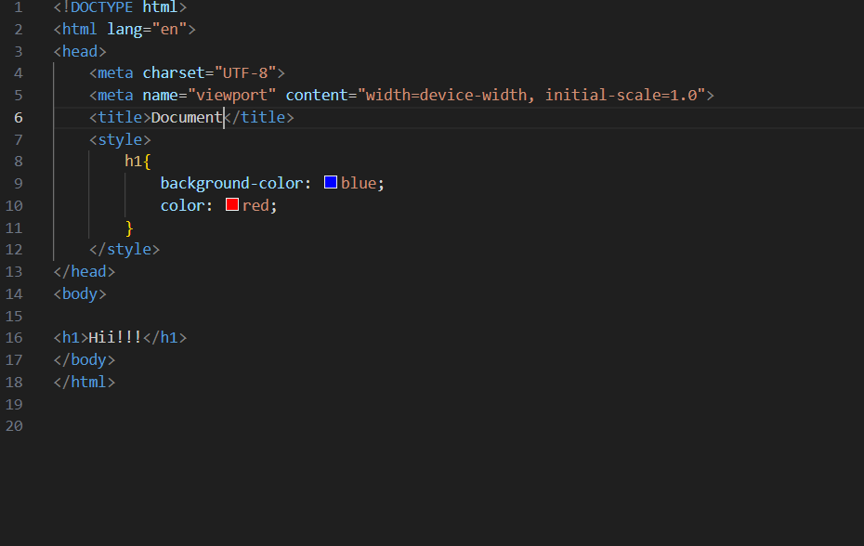

Output:

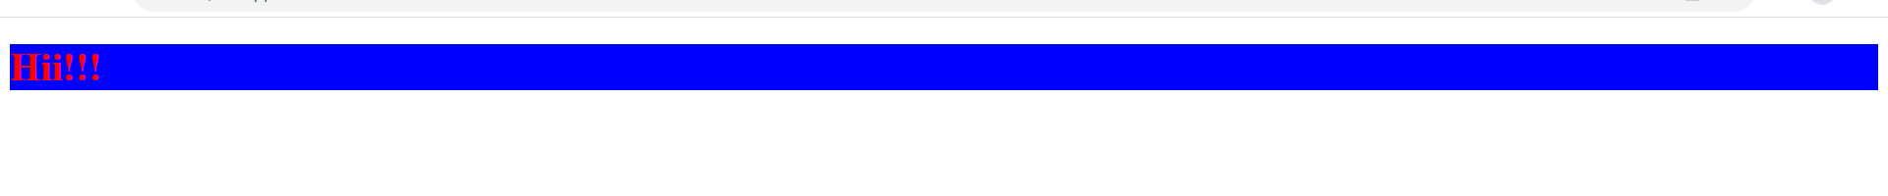

**15. What are the external style sheets?**

Ans:-

* External style sheets means to load css from different files.

Ex:-

Output:-

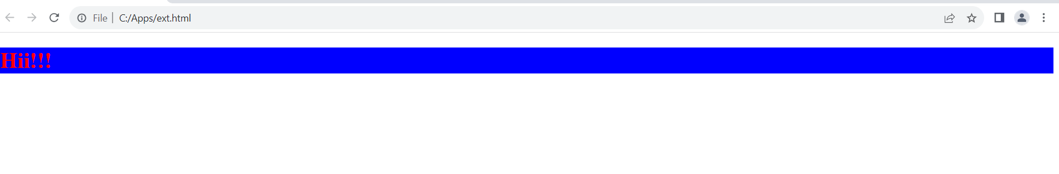

**16. What are the advantages and disadvantages of using external style sheets?**

Ans.

* Advantages :-

1. It makes the code cleaner.
2. Easy to read
3. Make changes on multiple file.

* Disadvantages:-

1. The page may not be rendered correctly until the external css is loaded.
2. Uploading or linking to multiple css file can increase your site’s download time.

**17. What is the meaning of the CSS selector?**

Ans:-

* The css seclector is used to find or select the html elements you want to style.
* It is a pattern of elements and other terms that tell the browser which HTML elements should be selected to have the CSS property values inside the rule applied to them.

Ex:-

Html:-

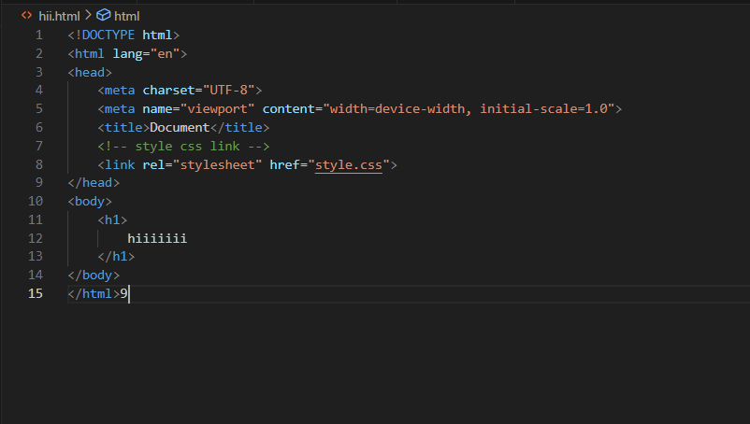

Css:-

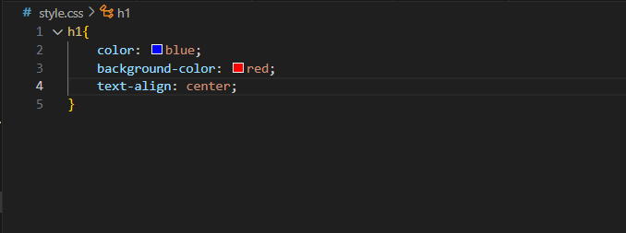

Output:-

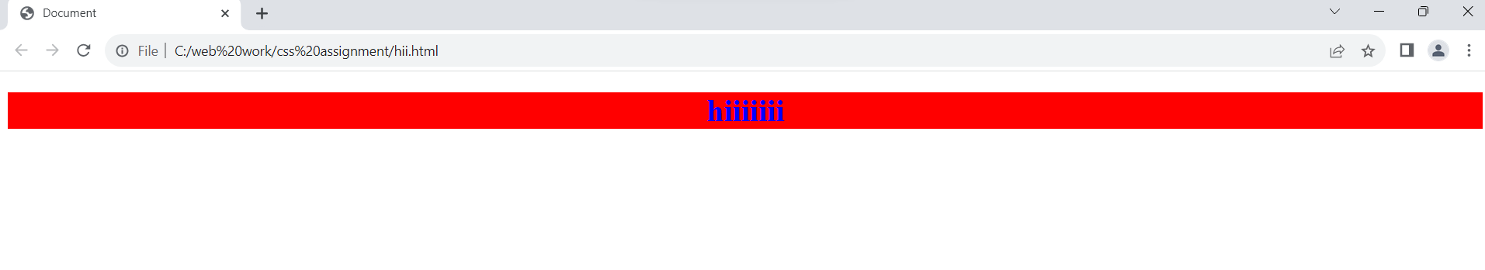

**18. What are the media types allowed by CSS?**

Ans.

The media type allowed by css is all type of medias are allowed such as mp3, mp4, png, jpeg, gif, etc…

Ex:-

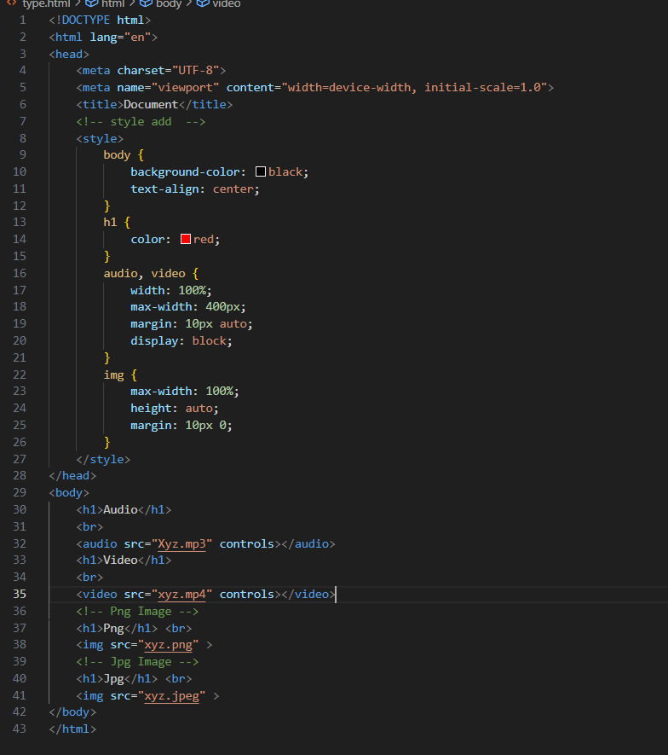

Output:-

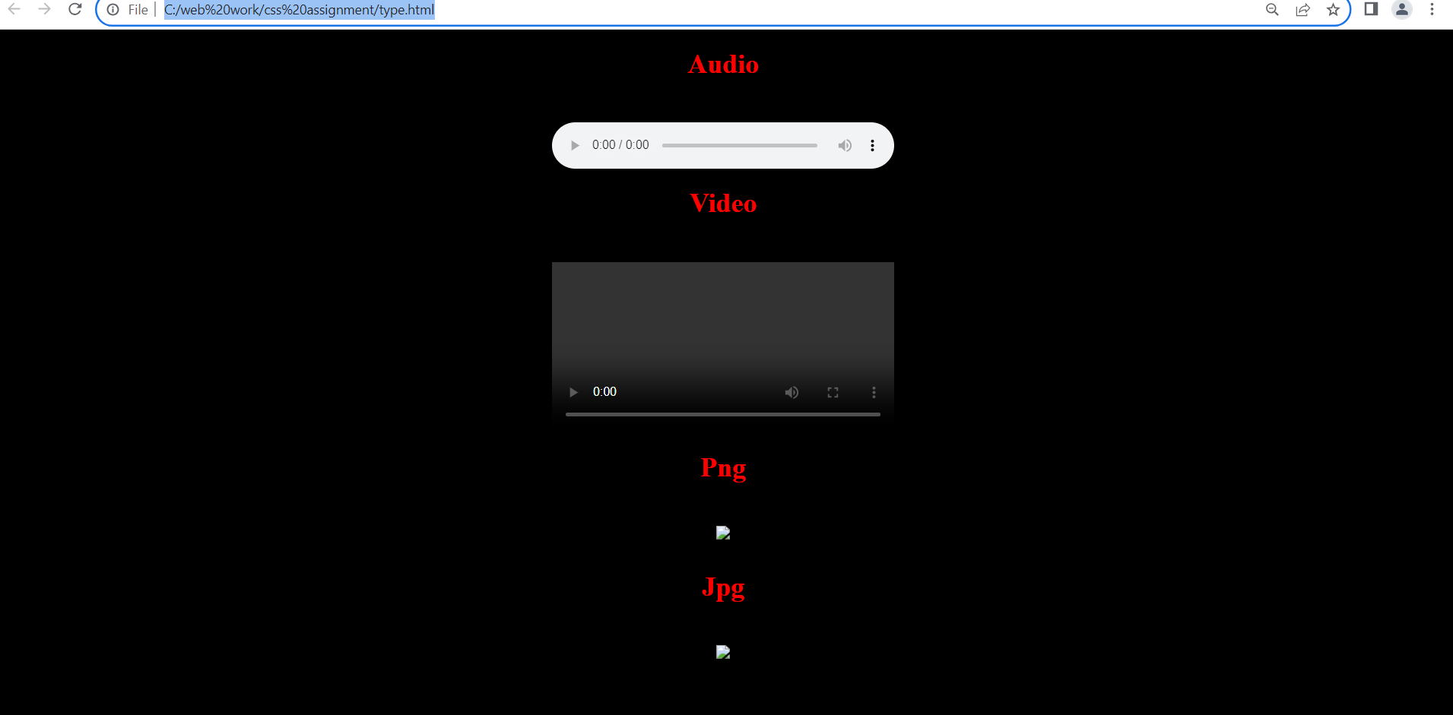

**19. What is the rule set?**

Ans:-

CSS rule set is contains one or more selectors and one or more declarations.

Ex:-

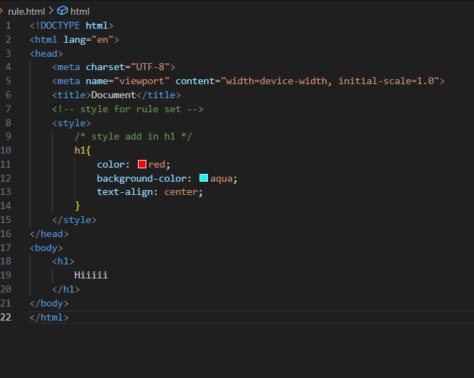

Output:-

